**NEURAL NETWORK INTUITION**

**INTRODUCTION:**

**This course focuses on neural networks and decision trees, two powerful machine learning algorithms, while providing practical advice for building effective machine learning systems.**

**NEURONS AND BRAIN:**

**History and Motivation of Neural Networks**

* **Neural networks were initially designed to mimic the learning processes of the human brain, with roots dating back to the 1950s.**
* **Despite falling in and out of favor over the decades, they gained renewed interest around 2005, particularly under the term "deep learning."**

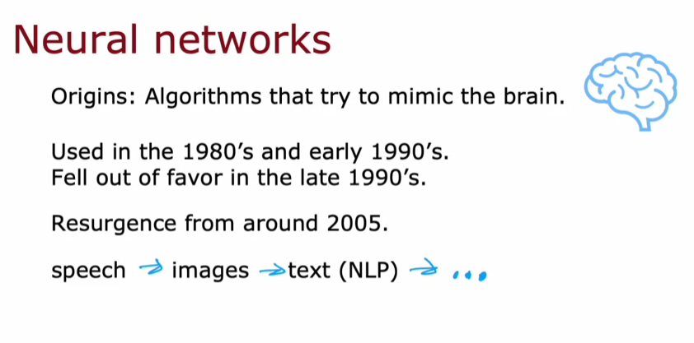

**Functionality of Biological and Artificial Neurons**

* **Biological neurons communicate through electrical impulses, with inputs received via dendrites and outputs sent through axons.**
* **Artificial neurons simplify this process by taking numerical inputs, performing computations, and producing numerical outputs, often working in networks.**

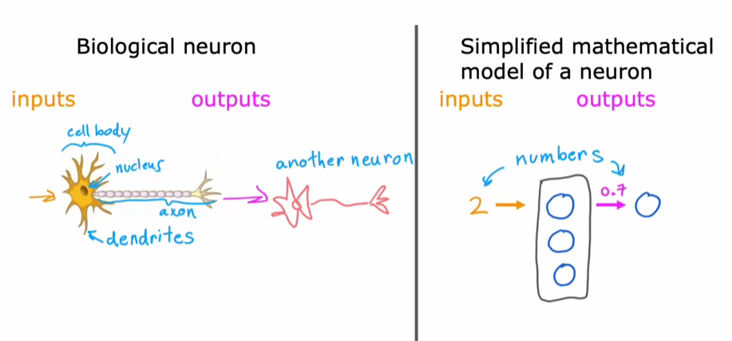

**Advancements and Applications**

* **Modern neural networks have revolutionized fields such as speech recognition, computer vision, and natural language processing, leading to breakthroughs in various industries.**
* **The rise of big data and powerful computing hardware, like GPUs, has enabled the training of larger neural networks, enhancing their performance significantly.**

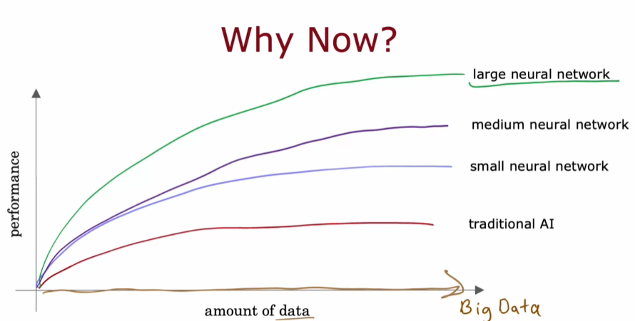

**DEMAND PREDICTION**

**Understanding Neural Networks**

* **Neural networks consist of interconnected neurons that process input data to make predictions. Each neuron can be thought of as a simple computer that takes inputs, applies a function, and produces an output.**

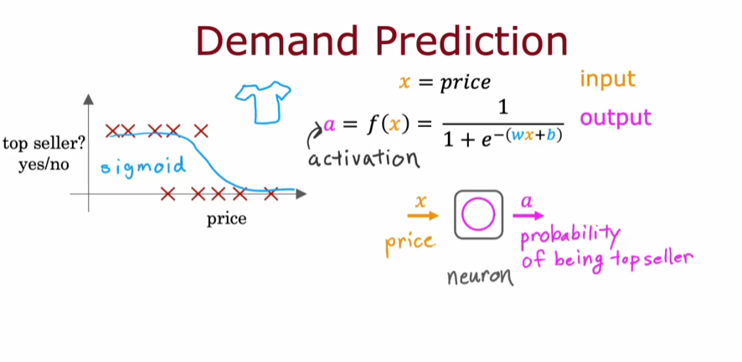

**The example of predicting whether a T-shirt will be a top seller illustrates how input features like price, shipping costs, marketing, and material quality can influence the output.**

**Layers in Neural Networks**

* **Neural networks are structured in layers: the input layer receives the initial data, hidden layers process the data, and the output layer provides the final prediction.**
* **Each layer can consist of multiple neurons, and the hidden layer is where the network learns to create new features that improve prediction accuracy.**

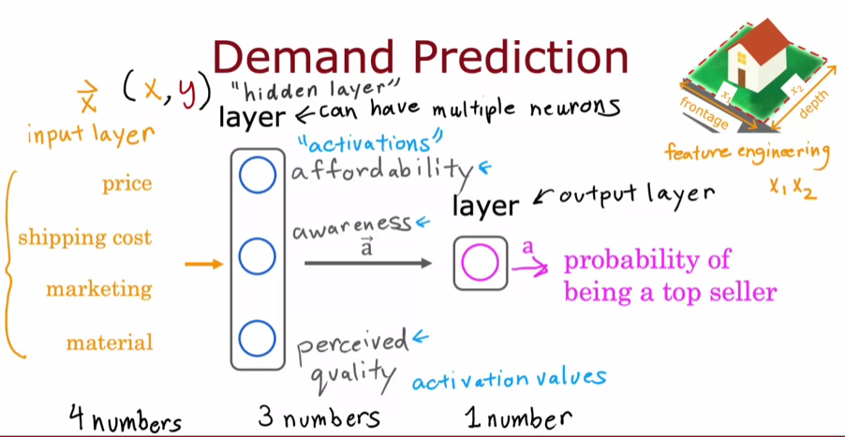

**Learning Features Automatically**

* **One of the strengths of neural networks is their ability to learn relevant features from the data without manual feature engineering, making them powerful tools for various applications.**
* **The architecture of a neural network, including the number of hidden layers and neurons, can significantly impact its performance, and this is an important consideration when designing a neural network.**

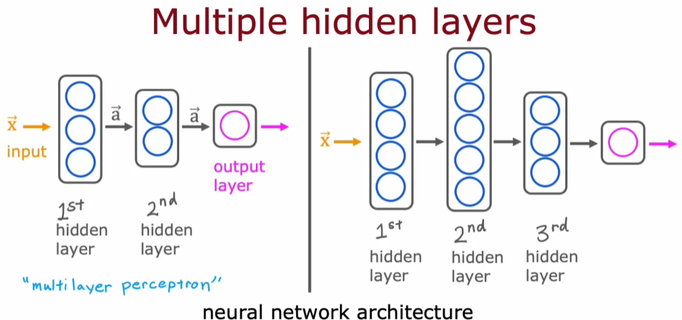

**EXAMPLE: RECOGNISING IMAGES**

**Understanding Neural Networks in Face Recognition**

* **A neural network can be trained to take an image as input and output the identity of the person in that image, using a grid of pixel intensity values (1,000 by 1,000 pixels).**
* **The input image is transformed into a vector of one-million-pixel intensity values, which the neural network processes through multiple hidden layers.**

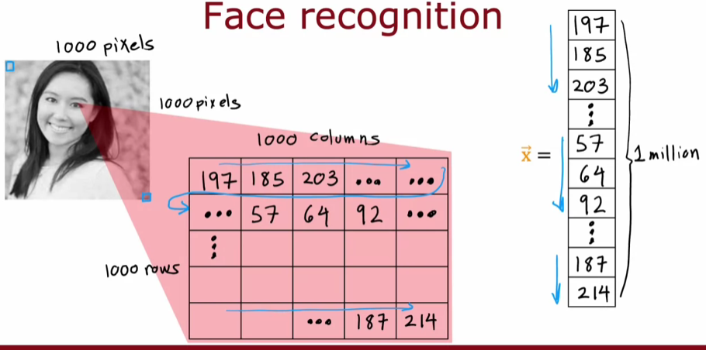

**Feature Detection in Hidden Layers**

* **In the first hidden layer, neurons detect simple features like edges and lines, while subsequent layers group these features to identify parts of faces, such as eyes and noses.**
* **The final hidden layer aggregates these parts to recognize complete face shapes, allowing the output layer to estimate the probability of the person's identity.**

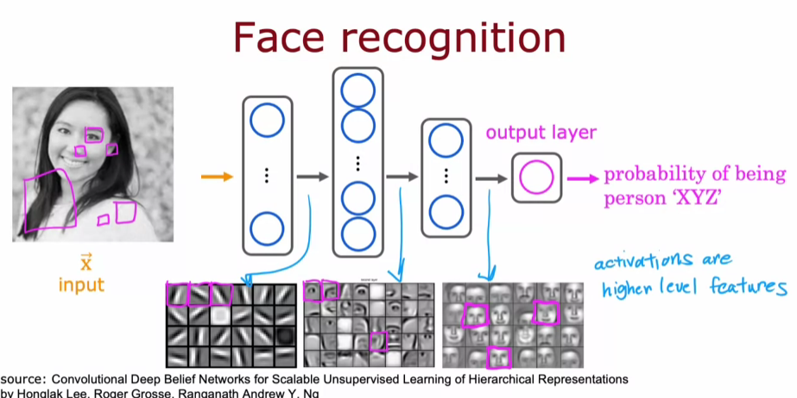

**Learning from Different Datasets**

* **When trained on different datasets, such as images of cars, the neural network learns to detect relevant features specific to that dataset, demonstrating its adaptability.**
* **This ability to learn feature detectors autonomously from data is a remarkable aspect of neural networks.**